**Opensource alternatives to paid SaaS**

Here are 10 opensource free software that you can use to replace your subscriptions with other SaaS

**An alternative to AirTable is NocoDB**

You can build your entire database like a spreadsheet on NocoDB, it’s a no-code platform so you don’t need to learn things to use it too.

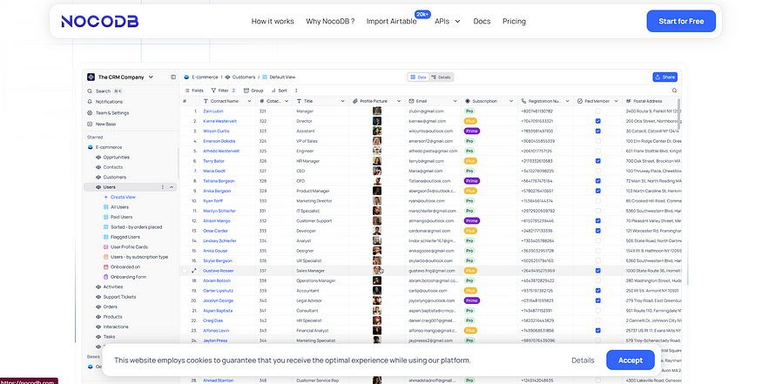

Screenshot of page: <https://nocodb.com/>

*Website URL:*[*https://nocodb.com/*](https://nocodb.com/)

**An alternative to Vercel is Coolify**

Coolify is an open-source alternative to Vercel and other hosting providers like Netlify.

You though need to have some technical background to set this up on your cloud. They even have a self-hosted version that you can try.

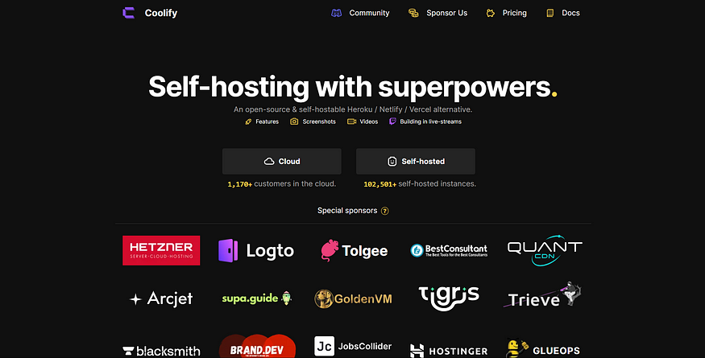

Screenshot of page: <https://coolify.io/>

*Website URL:*[*https://coolify.io/*](https://coolify.io/)

**An alternative to JIRA is Wekan**

If you are using JIRA for task management with your team, and paying for it, then you should check Wekan which is an open-source kanban board.

It is also an alternative to Trello.

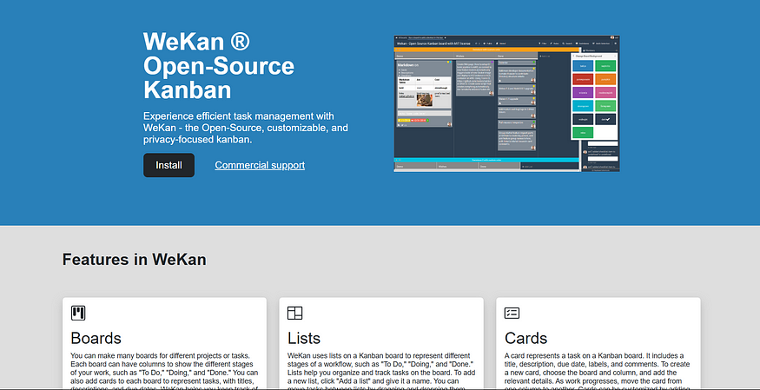

Screenshot of Page: <https://wekan.github.io/>

*Website URL:*[*https://wekan.github.io/*](https://wekan.github.io/)

**An alternative to DataDog is Prometheus**

As you know DataDog is a platform that helps you to analyze and track the metrics of your application's underlying architecture.

You can try Prometheus which is free and open-source and does all the same work as DataDog.

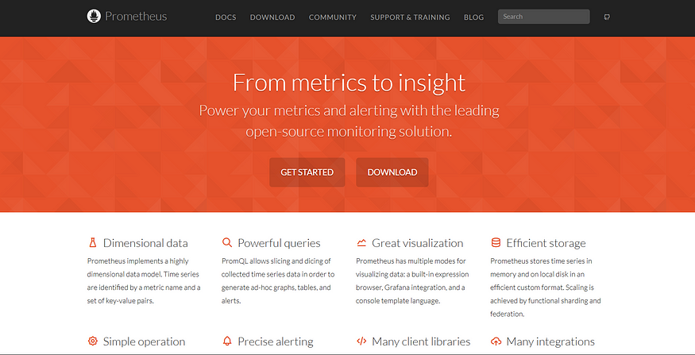

Screenshot of Page: <https://prometheus.io/>

*Website URL:*[*https://prometheus.io/*](https://prometheus.io/)

**An alternative to DropBox is NextCloud**

Just like DropBox NextCloud is an on-premise open-source content management platform, that you can deploy at your end.

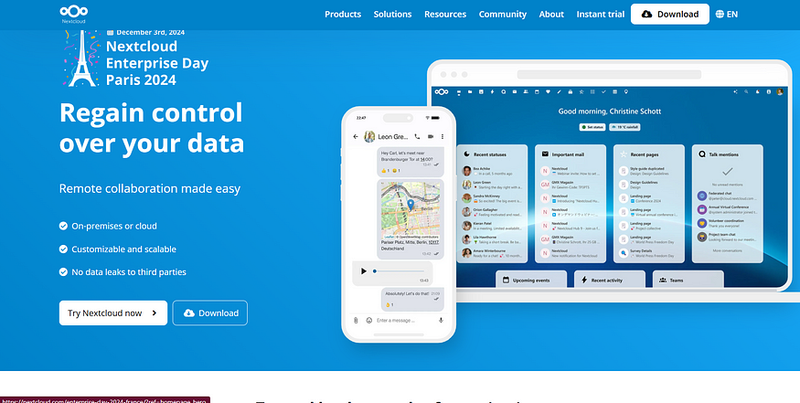

Screenshot of Page: <https://nextcloud.com/>

*Website URL:*[*https://nextcloud.com/*](https://nextcloud.com/)

**An alternative to Asana is OpenProject**

OpenProject is a free open-source project management tool, that provides similar features to Asana.

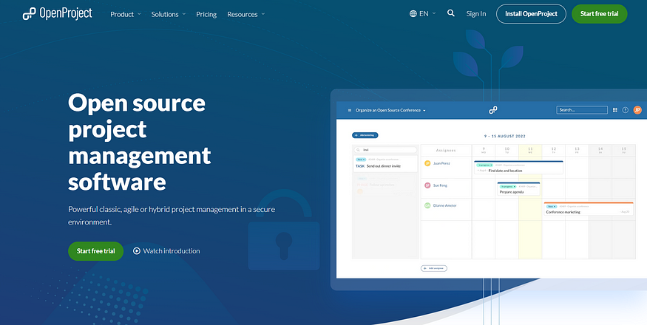

Screenshot of Page: <https://www.openproject.org/>

*Website URL:*[*https://www.openproject.org/*](https://www.openproject.org/)

**An alternative to Firebase is Convex**

Unline Firebase Convex provides you the backend for, serverless functions, file storage, CRON Jobs, vector search, caching, and much more.

There are other alternatives too for Firebase like, PocketBase and Supabase, but among them, I like Convex the most.

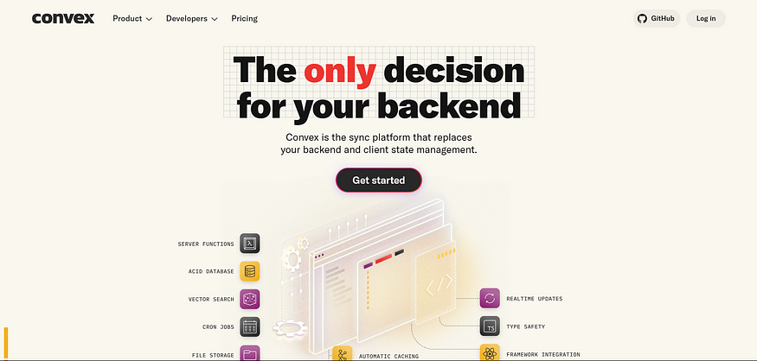

Screenshot of Page: <https://www.convex.dev/>

*Website URL:*[*https://www.convex.dev/*](https://www.convex.dev/)

**An alternative to Docusign is Docuseal**

There will be times when you want to sign your PDFs or any other documents, for that you should check Docuseal which is open-source.

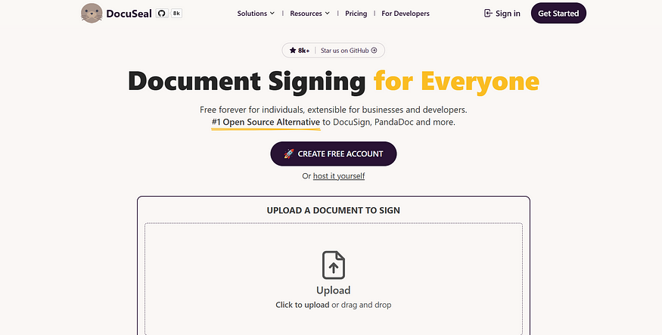

Screenshot of Page: <https://www.docuseal.com/>

*Website URL:*[*https://www.docuseal.com/*](https://www.docuseal.com/)

**An alternative to Heroku is Dokku**

Dokku is a free and open-source PaaS, which you can use to deploy your backend just like Heroku.

It has all the same settings like domains, keys, and installation just like Heroku.

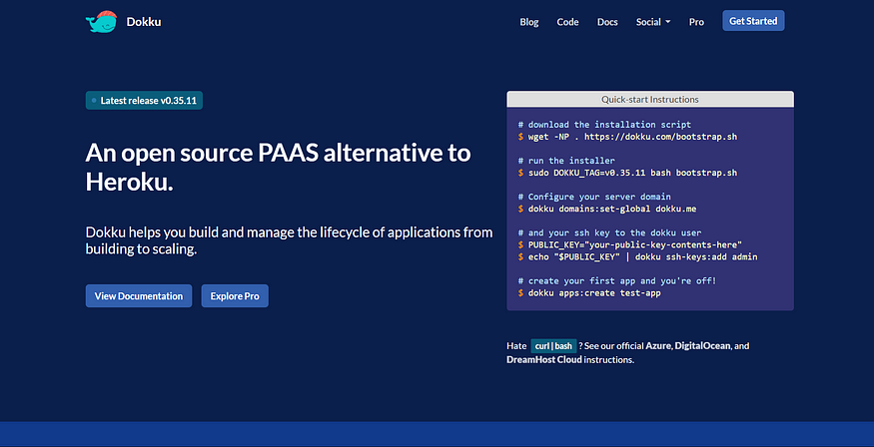

Screenshot of Page: <https://dokku.com/>

*Website URL:*[*https://dokku.com/*](https://dokku.com/)

**An alternative to Notion is Appflowy**

Most of us must have used Notion, Appflowy is the same in that, they have their sefl-hosted version and also an open-source one that you can check on their GitHub repo and use for your work.

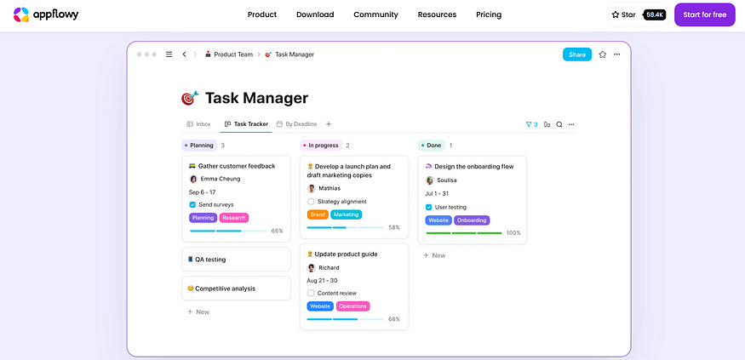

Screenshot of Page: <https://appflowy.io/>

*Website URL:*[*https://appflowy.io/*](https://appflowy.io/)

These were some of the free open-source alternatives to the paid SaaS that you can use in your businesses.

Let me know in the comments if you feel there is something else that you like to share I would love to check it out too.

I have also written a book on marketing if you want to take a deep dive into marketing and know how to get long-term paying customers for your SaaS, then you should check this book **“**[**Marketing Strategies to Grow Your SaaS**](https://shivanshudev.gumroad.com/l/marketingstrategy)**”.**